

*Prepared for*

**Sunday, 26 June 2011**

**Version**

**Revision and Signoff Sheet**

**Change Record**

|  |  |  |  |
| --- | --- | --- | --- |
| **Date** | **Author** | **Version** | **Change reference** |
| 10/11/2010 | Mark Stevenson | 2.2 | Updated for new DDC 3.0 update |
| 11/30/2010 | Mark Stevenson | 2.3 | Added additional service manager config steps |
| 12/15/2010 | Mark Stevenson | 2.4 additional MP configuration added | SCSM MP Revisions |
| 3/17/2010 | Mark Stevenson | 3.1 | Added SCOM MP info to SCOM Service setup |
| 3/21/2010 | Mark Stevenson | 3.2 | Updated errata on SCVMM service setup |

**Reviewers**

|  |  |  |  |
| --- | --- | --- | --- |
| **Name** | **Version approved** | **Position** | **Date** |
|  |  |  |  |
|  |  |  |  |
|  |  |  |  |

**Table of Contents**

1 Executive Summary 1

2 Introduction 4

2.1 Purpose 4

2.2 Out of Scope 4

2.3 Audience 5

2.4 Pre-Requisites 5

3 DDC Overview 7

4 DDC Hardware Infrastructure 10

4.1 Configuring a 2 Node High Availability Cluster (lab deployment) 10

5 DDC SOFWARE - Management 12

5.1 Systems Center Virtual Machine Manager 2008 12

5.2 Systems Center Operations Manager 2007 R2 14

5.3 Systems Center Configuration Manager 2007 R2 17

5.4 System Center Data Protection Manager 2010 19

6 DDC SERVICES – Toolkit 21

6.1 Installing the SCVMM Service 24

6.2 Installing & Configuring the Monitoring Service 27

6.3 Installing & Configuring the Configuration Management Service 29

6.4 Installing & Configuring Data Protection Manager Service 29

6.5 Installing & Configuring Service Manager Service 30

7 DDC Toolkit - Services 31

7.1 System Center Virtual Machine Manager (SCVMM) Service 32

7.2 Monitoring Service 36

7.3 Configuration Service 37

7.4 Data Protection Manager Service 39

10 DDC CLIENT & CONTROL PANEL INTEGRATION 40

Control Panel Integration from Microsoft .NET Platform 40

Building Silverlight based Demo Application 40

1. Install pre-requisites 40

1. Installers 44

Control Panel Integration from NON-Microsoft .NET Platform (example IBM/Java/PHP) 48

Figure 1: Figure showing relationship between DDC and the DDC Toolkit 2

Figure 2 Main Components of Dynamic Data Center (DDC) 8

Figure 3: Two Node Hyper-V Host Cluster w/Failover 11

Figure 4: DDC LAB Deployment of System Center Suite 12

Figure 5: Virtual Machine Manager 2008 Console after being fully deployed 14

Figure 6: Operations Manager 2007 R2 Single Server Deployment 15

Figure 7: Operations Manager 2007 R2 Console 16

Figure 8: Configuration Manager 2007 Console 18

Figure 9: DPM 2010 Admin Console 20

Figure 10: Logical Architecture of DDC Toolkit showing the DDC Services Layer interaction with Management and Presentation Layers 21

Figure 11: Deployment Diagram Showing the various Services deployed to respective Management Servers/Hyper-V 22

Figure 12: Ensure that the Web Server Role is Installed by using Server Manager Console 23

Figure 13: Ensure that WCF Activation is added as Feature using Server Manager Console 24

Figure 14- IIS 6 compatability 24

Figure 15: Virtualization Web Service Setup Dialog 25

Figure 16: Virtualization Web Service Installation Option(s) 26

Figure 29: Logical Architecture of DDC Services Layer showing the Separation of Interlaces & Implementation 32

Figure 30: Virtualization Service Contracts 36

Figure 31: Virtualization Service: Data Contracts 36

Figure 32: Monitoring Service UML Diagram 37

Figure 33: Configuration Service UML Diagram 38

Figure 34: DPM Service UML 39

Figure 40: Configure Service Reference Dialog 45

Figure 41: Collaboration Diagram showing Demo Application interaction 46

Figure 42: Add Service Reference Dialog 47

1. Executive Summary

Hosting Service Providers (HSPs) are constantly facing the challenge of responding to growing complexity, regulatory compliance, capacity, and availability, while ensuring manageability and efficiencies in their data centers. The emergence of Virtualization technology, and underlying hardware support for virtualization, and its broad acceptance by the industry has created new market opportunities for service providers to capitalize on virtualization technology to optimize Datacenters through server consolidation, and enhance server utilization and processing power, thereby reducing costs and complexity in the datacenter. This is done without sacrificing processing power and offering same or higher levels of SLA are, thereby reducing costs for customers through reduced power consumption, and resultant economies of scale. The challenge for HSP’s is how to make use of this unique market opportunity to harness the power of virtualization and ensure growth and manageability of the datacenter while increasing the range of managed services that they can provide to their customers.

The Dynamic Data Center (DDC) is part of initiative by the Communication Sector group within Microsoft to help hosting partners create a dynamic and scalable IT Infrastructure that responds and grows with the hosting provider’s business. The DDC enables the creation of a flexible and agile eco-system around the datacenter that enables organizational agility and also makes it possible for ISV’s and hosting partners to respond to new market opportunities. A dynamic and agile data center has several components to it including: hardware, software, and services.

There are three key “abilities” exposed in the dynamic datacenter. The first is high availability of server hardware, storage, network, connectivity, and support infrastructure. Secondly, to be enterprise ready, there is the need for the hosting provider’s virtualization technology to be scalable. The scalability requirement must extent to include server provisioning, patching, configuration management, end-to-end monitoring, backup and recovery. Thirdly, there is manageability and the need for a services layer that enables hosting partners to take advantage of the underlying product management capabilities. Through automation, these management abilities facilitate the creation of new types of managed services while empowering their customers.

In this white paper, we focus on the hardware and software infrastructure that make up the Dynamic Data Center, and how to setup and configure the DDC components in a LAB Environment, as well as the setup and configuration of automation services that are included as part of the DDC Toolkit.

The Dynamic Data Center Toolkit consists of software (web services) and a sample control panel application. The DDC Toolkit also contains documents outlining best practices for the creation and configuration of Dynamic Data Centers to meet the needs of the provider’s customers using proven technology and repeatable, documented process. The figure below illustrates how the DDC Toolkit exposes management functionality by providing a layer on top of the Microsoft Platform.



Figure 1: Figure showing relationship between DDC and the DDC Toolkit

The hardware infrastructure is detailed in vendor neutral way. We describe how Microsoft Software and Services can help hosting partners create an agile data center by enabling the underlying technologies and services that are part of the dynamic data center. We show how the DDC is made possible by using Microsoft Virtualization Technology based on Hyper-V and Windows Server 2008, and Microsoft System Center Enterprise Suite of applications that provide the end-to-end eco system for managing the Data Center. The System Center suite is composed of server based applications that help manage and optimize both physical and virtual infrastructure. The DDC setup in this document is geared towards creating a LAB/Pre-Production environment for testing and proof of concept. This configuration can form the basis for creating agile and scalable Data Center infrastructure in a production environment.

In this document we describe in detail how you can install and configure a sample services layer( included the Dynamic Data Center Toolkit). The services layer provides an abstraction layer to take advantage of the virtualization and management software in Windows and System Center. This document discusses how the service oriented architecture (SOA) makes it possible to take advantage of this layer from both Microsoft .NET based technology as well as non-Microsoft technologies such as Java/PHP. The architecture of the services layer is also described in detail to help hosting providers take advantage of the underlying technology. Hosting providers can leverage the services in their own environment to achieve a high degree of automation to achieve low touch or zero touch deployment. These systems can be integrated with the hosting providers control panel/management portal and backend systems. The appendix contains links to additional documents that you can peruse to get more in-depth knowledge around the surrounding technologies, such as Microsoft Hyper-V and System Center Enterprise. These documents are also included in the DDC Toolkit.

1. Introduction
   1. Purpose

The intent of this document is to help understand how Microsoft Software and Services help facilitate the creation of Dynamic Data Center (DDC). They do this by describing the underlying technologies, and by walking through the steps needed to establish a DDC in LAB environment. The lab is established using minimal Hardware, and by installing and configuring requisite software and services needed.

The software components include Windows Server 2008 Hyper-V, System Center Suite, and the DDC Toolkit. We start with a sample Silverlight based control panel that demonstrates the underlying technologies working together. The control panel application provides a rich customer experience that illustrates how services software can automate the creation of managed offerings that in turn can increase profitability of the HSP/ISP. The offerings are created while at the same time lowering costs, and reducing time to market for the hosting provider. Each of the components of the DDC is discussed in detail, with additional information found in the appendix.

This document is not intended to provide the means for establishing full scale production environment, which entails additional capacity planning, analysis, and investments in infrastructure. However, it is our intent to provide enough detail in this document that an ISP or HSP can take advantage of the information to and scale out for production scenarios. It must also be emphasized that the web services included in DDC Toolkit are not a production product, and carries no support from Microsoft. They are intended for illustration purpose only, and to provide a quick entry point for HSP’s/ISV’s to integrate their control panel/management portal with the management layer. The rest of the document is organized as follows:

1. What is the DDC? Overview of the DDC is provided in Section 3.
2. DDC hardware infrastructure is discussed in Section 4.
3. DDC management software (System Center) –installation & configuration is discussed in Section 5.
4. DDC software – services installation & configuration is discussed in Section 6.
5. Section 7 contains discussion of the software architecture of the WCF services.
6. How to setup the dev environment to consume the DDC Services from VS 2010; extend this with an ASP.net app - 1 simple page/service ... as time permits.

It is our hope and desire that HSP’s/ISP’s that wish to take advantage of MS technologies for the datacenter can do so now and do it in a way that helps them to capitalize on growing market for dynamic, virtualized, hosted, managed services thereby increasing profitability, and enabling HSP’s to go up the value chain.

* 1. Out of Scope

In this document, we do not discuss the physical infrastructure (housing), hardware, rack space, organization of data center, setting up Active Directory infrastructure, DNS, DHCP, ISA, networking, routers, switches, firewalls, connectivity, energy requirements, security, capacity planning, support, and personnel requirements for setting up and operating a data center. It is assumed that hosting service providers (HSP’s) will have pre-existing infrastructure or are in the process of establishing a datacenter with requisite capacity and support infrastructure. What is described in this document is how HSP’s can take advantage of Microsoft software and services, coupled with documentation in the DDC Toolkit, to build a flexible and dynamic datacenter.

* 1. Audience

The target audience is IT Directors/CTO’s, Managers, IT Architects, Systems Engineers, IT Developers, and technical staff of Hosting Providers/ISP’s who can use this document to gain an understanding of various components of the DDC, and implement it in their own environment, and thereby increase the type of managed services that they provide to their customers. This document will also be useful to anyone intending to get better understanding of Microsoft Technologies geared for the Data Center, and the services layer that enables one to automate the day-to-day tasks of running and maintaining dynamic data centers, whether it is on-premise, or off-premise.

* 1. Pre-Requisites

In order to have DDC installed and configure in LAB environment, we suggest that the following Hardware/Software be available:

**Hardware/Infrastructure**:

Two servers with similar hardware specs that will be used as Hyper-V a cluster.

•       SAN shared storage of 300GB accessible by the cluster.  Partition the shared storage equally into 4 40GB LUNs and one 140G LUN.

•       One additional LUN of 100MB for use as the quorum drive.

•       Ensure both your SAN firmware and/or HBA firmware supports iSCSI-3 persistent reservation mode.

•       A working AD environment and other infrastructure server roles.

•       A Windows Enterprise Server 2008 x64 sysprep'd image (if available) .

**Software (ISO Images or DVD’s for Installation)**

•       Install an ISO mounting tool on both nodes of the cluster.

•       Download the following ISO images onto either of the hosts:

•       SQL Server 2005 SP3 (x64)

•       Windows Server 2008 Enterprise (x64)

* Windows Server 2008 SP2 (x64)

•       System Center Virtual Machine Manager 2008 (x64)

•       System Center Data Protection Manager RTM and SP1 Update (x64)

•       System Center Operations Manager 2007 R2 (x64)

•       Microsoft Deployment Toolkit (MDT Update 4) or Sysprep’ed Images

Note that the above is minimal configuration for LAB based deployment of the DDC, pre-production and production environments require careful thought, capacity planning, and may entail additional physical machines and hardware for scalability, performance, and high availability reasons. Setting up such a production environment is beyond the scope of this document.

1. DDC Overview

In this section, we break down the various architectural components of the Dynamic Data Center built on Microsoft Technologies for the datacenter. The DDC architecture includes the hardware infrastructure, software, and services needed to complete the ecosystem for creating managed, automated, dynamic, agile, and flexible datacenter. In order to keep the document succinct, we provide references to individual DDC best practices and supporting documentation where deemed necessary. For additional details please refer to the following document named: “Dynamic Data Center Guidance.docx”. A case study of the DDC in practical use can be found by reviewing the document named: “[MaximASPCaseStudy.docx](http://www.microsoft.com/casestudies/Case_Study_Detail.aspx?CaseStudyID=4000002506)”.

In this document, the focus is on software and services components of the DDC. The coverage for hardware and infrastructure components is limited to providing the minimal hardware required for setting up the DDC in a lab environment. For additional hardware details, and setting up the network infrastructure, please refer to the appendix or the specific hardware manufacturer’s documentation. The software is broken up into virtualization software, and systems management software. The services layer is comprised of set of web services, and a sample application showcasing self-service customer portal that leverages the DDC services to provide an enhanced/self-managed user experience.

The components of the DDC are as follows:

1. Hardware Infrastructure.
2. Software comprising Microsoft Software for the Dynamic Data Center.
   1. Microsoft Hyper-V© based Virtualization built on Windows Server 2008.
   2. Microsoft System Center© Suite for Management and Operations.
3. Web wervices (based on WCF) that leverage the manageability and virtualization backend.
4. Supporting documentation, guidelines, and best practices found on <http://www.microsoft.com/hosting/dynamicdatacenter/Resources.html>

The following diagram shows the DDC and its components can be deployed:



Figure 2 Main Components of Dynamic Data Center (DDC)

As depicted above, the DDC comprises of four (4) or more Windows Server 2008 RTM servers running Microsoft System Center Enterprise Suite and a local or remote instance SQL Server 2005 SP3 or higher, as well as one or more Hyper-V host clusters for high availability. The host clusters are running the Hyper-V role of Windows Server 2008, and connected to backend iSCSI, Fiber Channel, or SeS based SAN for shared storage. They are clustered using Windows Server 2008 clustering technology. The WCF Services are also installed on individual System Center Enterprise Servers as described in the section on DDC SERVICES – Toolkit. Note that each Hyper-V host cluster can have up to 16 nodes (Host Servers); with each node typically running 10-20 Hyper-V based Virtual Machines (actual number may vary based on host capacity). Note that in LAB environment, a minimal of 2 Node Hyper-V host clusters is required to enable high availability and failover.

The management servers are used to run Microsoft System Center Enterprise, and can be deployed on either physical or virtual servers. It is recommended that physical machines be used for setting up production environment, and to use virtual machines in a LAB Environment. The Microsoft System Center® Enterprise software is powered by Windows Server 2008 and SQL Server 2005 (or higher). It is comprised of suite of applications that help you manage and optimize entire physical and virtual infrastructure within dynamic datacenter. The products within System Center (SC) 2007 Enterprise include:

* **System Center Virtual Machine Manager 2008**: VMM provides scalable infrastructure for managing virtual machines. It integrates with System Center Operations Manager 2007 to enable performance & resource optimization.
* **System Center Operations Manager 2007 R2:** Used for monitoring hardware, network, and software. R2 extends support to Linux based systems.
* **System Center Configuration Manager 2007 R2**: Used for software updates, configuration management, OS deployment, provisioning, inventorying etc.
* S**ystems Center Data Protection Manager 2007 w/SP1**: Used for protecting (short term/long term backup and recovery) physical and virtual machines, and disaster recovery.

Each of the management servers perform a specific role within dynamic and managed Datacenter, and therefore requires a separate Physical or Virtual Server, and supporting infrastructure such as SQL Server backend, SQL Reporting Services, Active Directory Accounts, PKI, and other infrastructure services such as DNS/DHCP etc. The management servers for System Center can be installed individually on a Single Server, Multi-Server (for load balancing/redundancy), as well as High Availability mode with either stand alone (local) instance of local or remote instance of SQL Server 2005, with optionally clustered instance of SQL Server 2005. For details refer to the section – DDC SOFWARE - Management.

The third component of DDC is the Services backend, consisting of WS-* (Web Services Open Standards) compliant services for integration with the control panel/web portal, and sample Silverlight based web application. These that showcase a customer centric self service portal that integrates with backend services. The WCF® based services are based on Microsoft’s Windows Communication Foundation (part of .NET 4.0 Framework) and support multiple protocols such as SOAP/HTTP. The following WCF services are provided as part of the DDC Toolkit:

* Virtualization WCF Service: This service geared toward interacting with Hyper-V API’s, and provides automation tasks such as provisioning and managing VM.
* Monitoring WCF Service: This service provides ability to monitor physical and virtual devices.
* Configuration Management WCF Service: This service provides the ability to perform software updates, patching, configuration management and other tasks.
* Data Protection Management Windows Service: This is a windows service that is accessible from Http endpoint, that provides backup and recovery services.

The services layer is described further in the section on DDC Services – Toolkit.

1. DDC Hardware Infrastructure

Any successful implementation of Dynamic Data Center requires careful analysis and capacity planning to meet current and future growth. The requirements for each hosting service provider are unique, and dependant on various factors such as hoster’s competencies, specific market and customer base, and their growth potential. A detailed description of planning for dynamic datacenter infrastructure is beyond the scope of this document, for details the reader is referred to Microsoft Infrastructure Planning and Design (IPD) Guides available from [www.microsoft.com/IPD](http://www.microsoft.com/IPD).

The Hardware infrastructure for DDC is designed to support the following goals:

* High Availability of Virtual Machines, with Automatic Failover (also called Quick Migration)
* Network Redundancy & High Availability
* Ability to Provision new Virtual Machines using Light Touch or Zero Touch Deployment

*For more Information on the Hardware Infrastructure, Refer to the following section of Windows HDA Documentation:*

* *Setting up High Availability*
* *Setting up Shared Storage*

*????*

* Performance and Resource Optimization (PRO) of Physical and Virtual Infrastructure through functionality provided through integration between System Center Operations Manager 2007 R2 and Systems Center Virtual Machine Manager 2008.
* Large Shared Storage based on SAN technology (such as iSCSI, Fiber Channel, SeS) for VHD’s, Pass-Through Disk were needed.
* System Center Enterprise Suite (including the 4 core products – SC-CM, SC-OM, SC-DPM, and SC-VMM).
* Running WCF Services and Demo Instance
  1. Configuring a 2 Node High Availability Cluster (lab deployment)

Here we describe how to setup a 2 Node High Availability Hyper-V Host Cluster using Windows Server 2008 RTM and Hyper-V RTM. In order to set up 2 Node High Availability Cluster, the following hardware configuration is needed:



Figure 3: Two Node Hyper-V Host Cluster w/Failover

The following describes high level steps required to set up 2 Node High Availability Cluster, with references to appropriate documentation in the DDC Toolkit, as follows:

1. Ensure that the physical hardware meets the requirements for Hyper-V based virtualization, such as Intel or AMD x64 with Hyper-V support.
2. Refer to the Document: “[*Provisioning Hyper-V Virtual Machine in Hosting Environment.docx*](http://download.microsoft.com/download/A/2/F/A2F199C0-672E-44E6-BF1D-878E233C3F08/ProvisioningHyper-VVirtualMachineinHostingEnvironment.docx)” to get an overview of the Hyper-V provisioning process related to hosting providers.
3. If the servers are being deployed on bare hardware, the Windows Server 2008 x64 operating system must be deployed, along with any drivers and OS features. There are various techniques available for provisioning bare hardware, such as using Syprep’ed images, using a tool such as Microsoft Deployment Toolkit (MDT), or Windows imaging techniques. Each technique has its own benefits and advantages. Please refer to the following document to determine the best option for provisioning the operating System: “[*Operating System Imaging with Windows Server 2008 R2.docx*](http://code.msdn.microsoft.com/Project/Download/FileDownload.aspx?ProjectName=ddc&DownloadId=14027)”.
4. DDC SOFWARE - Management

The management software is comprised of the System Center Enterprise Suite of applications. In the next couple of sections, we discuss each of the products, and their installation in the DDC LAB environment. Please note that in the case of production environment, the hardware requirements are going to be different than in virtual environment. Additionally, failover and scalable installations require multiple and redundant hardware, which is not discussed here. A detailed description of products that comprise the System Center Suite and their capabilities is beyond the scope of this document, the user is referred to: <http://www.microsoft.com/systemcenter/en/us/default.aspx>.

In order to setup the System Center LAB Environment, the following servers, a minimum of 4 Windows Server 2008 servers are needed, as shown in the physical architecture below; each of these servers could be physical or virtual. Note that in production environment, we recommend high end physical machines in scalable configuration.



Figure 4: DDC LAB Deployment of System Center Suite

* 1. Systems Center Virtual Machine Manager 2008

Virtual Machine Manager 2008 is a component of System Center Enterprise Suite, and is used for managing virtual machine infrastructure.

**Install & Configure Virtual Machine Manager 2008**

To install System Center Virtual Machine Manager 2008, please follow the following steps:

1. Capacity Planning: On the Infastructure Planning and Design, review the following documents <http://technet.microsoft.com/en-us/solutionaccelerators/ee395429.aspx>
2. Review the latest Pre-Requisites for Deploying Virtual Machine Manager 2008 online at TechNet: <http://technet.microsoft.com/en-us/scvmm/default.aspx>
3. Provision a Physical or Virtual Machine to install the VMM 2008 Server (for instance, DDC-SC-VMM01).
4. Install necessary VMM Pre-requisites, including any service packs, and any dependant software such as SQL Server 2005 w/SP3. Refer to TechNet documentation for installing System Center VMM 2008 on single server at: <http://technet.microsoft.com/en-us/library/cc764289.aspx>.
5. Install Virtual Machine Virtual Machine Manager per TechNet documentation and “New Installation of VMM 2008” at <http://technet.microsoft.com/en-us/library/cc793149.aspx>.

**VMM 2008 Post Installation Tasks**

Once Virtual Machine Manager 2008 is installed, perform the following tasks:

1. Ensure that you can launch the VMM 2008 console as shown in Figure 5 below.
2. Create one or more Host Server Groups.
3. Add the cluster created earlier to the host.
4. Ensure that you can see the virtual machines that are provisioned in the host cluster.
5. Create and configure the library server. Add any VHD’s and ISO images to the library.
6. Create hardware/software templates.
7. Set/configure high availability options for virtual machines.
8. If Integrating with VMWare ESX server, add the ESX host or cluster to the VMM Group.

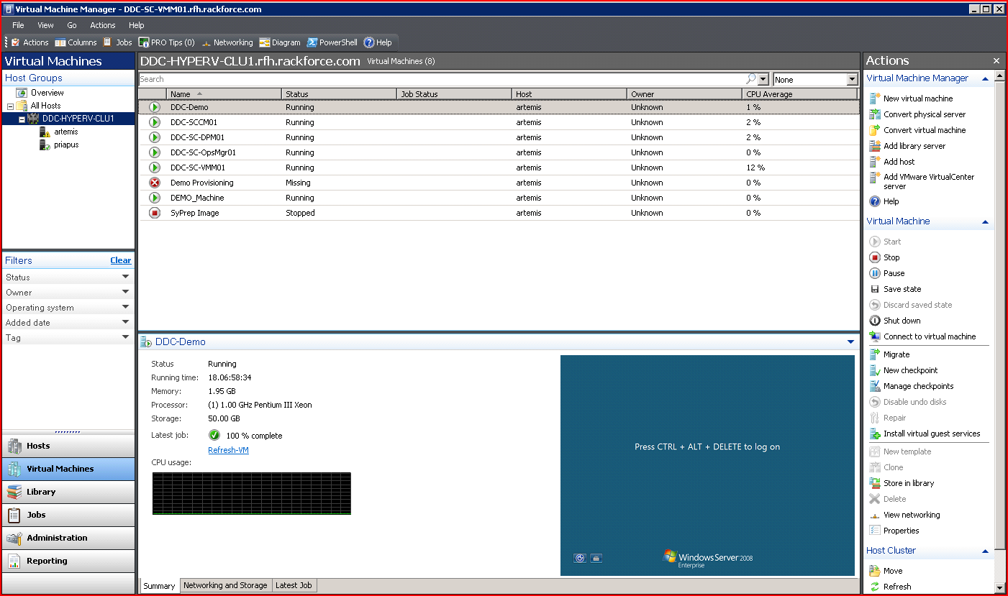

Figure 5: Virtual Machine Manager 2008 Console after being fully deployed

* 1. Systems Center Operations Manager 2007 R2

Operations Manager 2007 R2 is component of System Center Enterprise, and provides end-to-end service management of applications and IT services running across data center fabric, providing greater control and insight into health and performance of Microsoft, UNIX, and Linux servers, and the workloads running on them. For an overview of Systems Center Operations Manager 2007, please refer to the site: <http://www.microsoft.com/systemcenter/en/us/default.aspx>.

**Install & Configure Operations Manager 2007 R2**

To install System Center Operations Manager 2007 R2 in DDC Lab Environment, please follow the following steps:

1. “*Getting Started with Operations Manager 2007 R2*” on TechNet at: <http://technet.microsoft.com/en-us/library/dd887701.aspx> .
2. Review “*Operations Manager 2007 R2 Planning Guide*” at: <http://technet.microsoft.com/en-us/library/dd789005.aspx> and IPD guide in “[*http://technet.microsoft.com/en-us/solutionaccelerators/ee395430.aspx*](http://technet.microsoft.com/en-us/solutionaccelerators/ee395430.aspx)*”.*
3. Determine the specific deployment scenario for installing Operations Manager 2007 R2 by reviewing the TechNet article “Operations Manager 2007 Deployment Scenarios” found at: <http://technet.microsoft.com/en-us/library/bb432145.aspx>. Note that in a lab environment, a single server, single management group scenario is recommended, as shown below:

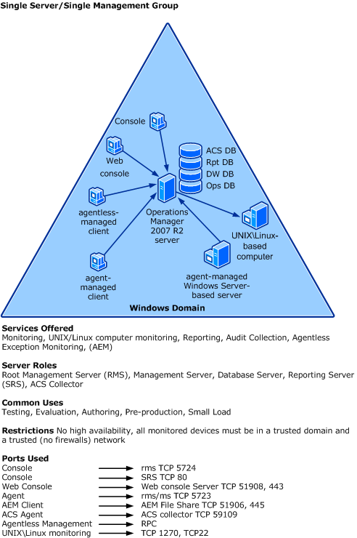

Figure 6: Operations Manager 2007 R2 Single Server Deployment

1. Review the pre-requisites for deploying Operations Manager 2007 R2 online at TechNet: <http://technet.microsoft.com/en-us/library/bb432131.aspx>.
2. If needed, provision a physical or virtual machine needed for installing the Operations Manager 2007 R2 Server (for instance, DDC-SC-OM01).
3. Install necessary Operations Manager 2007 R2 pre-requisites, including any service packs, and any dependant software such as SQL Server 2005 w/SP3, and SQL Reporting Services. For Details refer to the appropriate section of the Document: “[*System Guide for System Center Enterprise Suite.docx*](http://windowshda.com/HDA/Contents/SystemCenter/System%20Center/Overview/Installation%20Guide%20for%20System%20Center%20Enterprise%20Suite.docx)”, found in the DDC Toolkit. Refer to TechNet documentation “*Deploying the Single Server, Single Management Server Scenario*” at <http://technet.microsoft.com/en-us/library/bb432146.aspx>.
4. Once Ops Manager 2007 R2 is installed, verify that you can launch the Administrative Console as shown below:

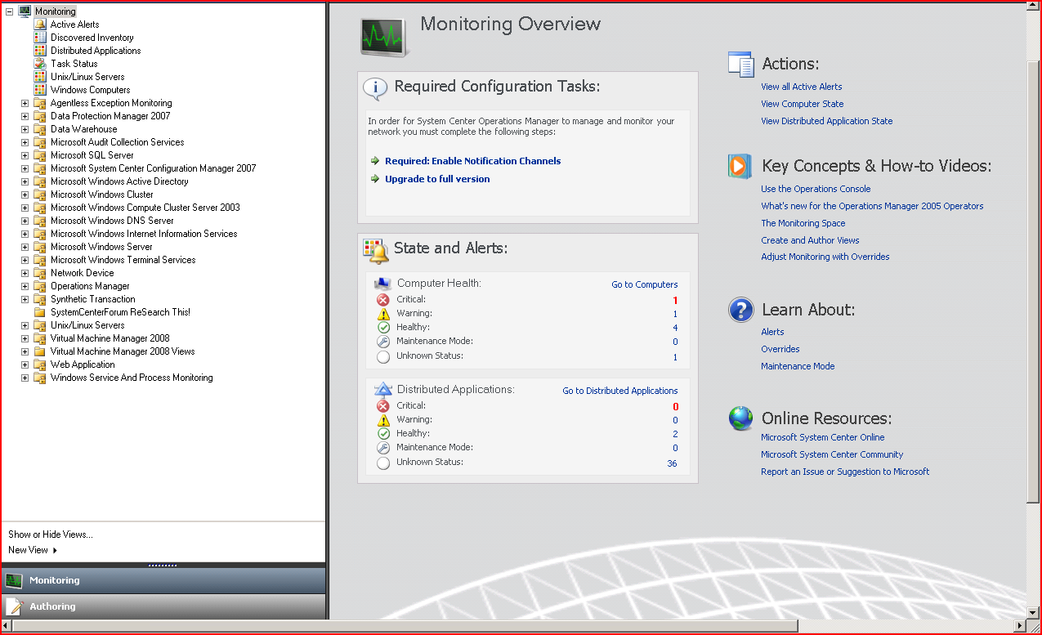

Figure 7: Operations Manager 2007 R2 Console

1. Follow post-installation configuration steps as detailed below.

**Operations Manager 2007 R2 Post Installation Steps**

One you have installed Operations Manager, implement the following steps:

1. Review the online documentation on “*Configuring Operations Manager 2007 R2*” on TechNet at: <http://technet.microsoft.com/en-us/library/cc540365.aspx>.
2. Install and deploy operations management agents on each computer and device being managed.
3. Install Operations Manager 2007 R2 Management Packs. Management packs help manage the health of specific objects and components. Please refer to the Operations Manager software catalog at <http://technet.microsoft.com/en-us/opsmgr/cc539535.aspx> for list of the management packs for Ops Manager that are available for download. The following Management Packs are Recommended:
   1. Windows Server 2008 (Windows Server)
   2. Hyper-V
   3. DPM 2007
   4. Configuration Manager 2007
   5. Operations Manager management pack
   6. SQL Server
   7. Internet Information Services (IIS) Manager
4. Ensure PRO Functionality by installing requisite components on VMM 2008 and Ops Manager 2007 R2 servers.
5. Set up monitoring of computers and devices.
6. Set up alerts and tasks.
7. Create views.
8. Author management packs as needed.
   1. Systems Center Configuration Manager 2007 R2

Configuration Manager 2007 R2 is a component of System Center Enterprise, and is used for assessing, deploying, updating servers, clients, and devices, across physical and virtual infrastructure. For details about Configuration Manager 2007 R2, please refer the Configuration Manager Product Portal page at: <http://www.microsoft.com/systemcenter/configurationmanager/en/us/default.aspx>.

**Installation of System Center Configuration Manger 2007 R2**

To install System Center Configuration Manager 2007 R2, please follow the following steps:

1. Guidance: <http://technet.microsoft.com/en-us/library/bb693806.aspx>
2. Review the latest Pre-Requisites for Deploying Configuration Manager 2007 R2 online at TechNet: <http://technet.microsoft.com/en-us/scvmm/default.aspx>
3. Provision a physical or virtual machine to install the Configuration Manager 2007 Server (for instance, DDC-SC-CM01) and R2 update.
4. Install necessary Configuration Manager 2007 R2 pre-requisites, including any security packs and OS Service Packs, and any dependant software such as SQL Server 2005 w/SP3. For Details refer to the TechNet guide at <http://technet.microsoft.com/en-us/library/bb694113.aspx> for latest pre-requisites. Note that in order to install Configuration Manager 2007 R2, you need to install Configuration Manager 2007 SP1, and then apply the R2 Update.
5. Refer to TechNet documentation for installing Configuration Manager 2007 R2 for single server at: <http://technet.microsoft.com/en-us/library/bb632990.aspx>. Install Configuration Manager 2007 R2 per the document “Installation *Guide for System Center Enterprise Suite.docx*”.
6. Follow Post-Installation Configuration steps as detailed below.

**Configuration Manager 2007 R2 Post Installation Configuration**

The following tasks are required to complete the Installation of Configuration Manager 2007 R2.

1. Ensure that Configuration Manager Site Server has been installed correctly by launching the Configuration Manager 2007 R2 Console and verifying the Site Configuration as shown below.

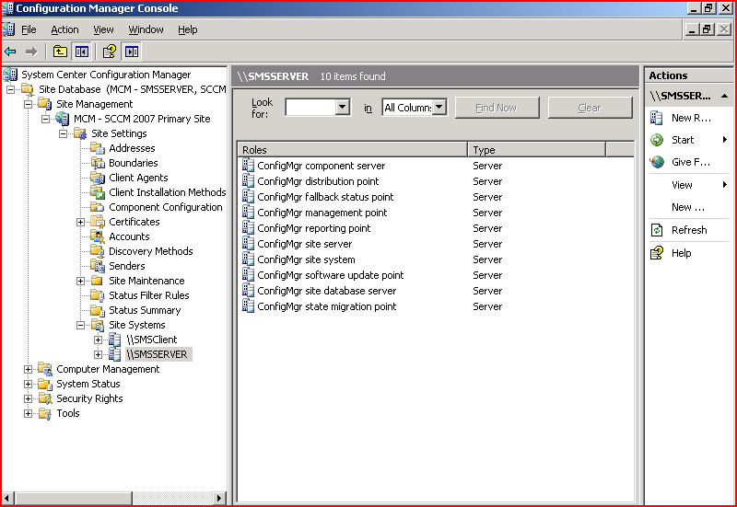

Figure 8: Configuration Manager 2007 Console

1. Refer to the Tasks List for “Configuration Manager Tasks for Single Site System” on TechNet at: <http://technet.microsoft.com/en-us/library/bb694280.aspx>. In general, the following configuration tasks are recommended:
   1. Specify the configuration management boundary
   2. Configure the default management point for a site
   3. Configure Site Systems (i.e. computers running Configuration Manager 2007 Roles).
   4. Configure Site System Roles. The following roles may be needed:
      1. ConfigMgr Site Server
      2. ConfigMgr Site System
      3. ConfigMgr Management Point
      4. ConfigMgr Software Update Point
      5. ConfigMgr Reporting Point
      6. ConfigMgr Distribution Point
   5. Configure site components for status reporting, SQL Server Reporting etc.
2. Review Configuration Manager features at <http://technet.microsoft.com/en-us/library/bb680550.aspx>. A detailed walkthrough of each for the features is beyond the scope of this document, please refer to online documentation.
3. Create/Modify collections. Collections in Configuration Manager are a way of organizing users.
4. Deploy Configuration Manager clients. The steps required for installing clients include:
   1. Configure the management point
   2. Determine if server locator point is needed.
   3. Configure the fallback status point and reporting point.
   4. Install the ConfigMgr client.
   5. Configure client agents.
5. Configure operating system deployment.
6. Configure software distribution and maintenance Windows(s).
7. Configure integration with Windows Update Server (WSUS).
   1. System Center Data Protection Manager 2010

Systems Center Data Protection Manager (DPM) 2010 is a component of System Center Enterprise. DPM is used for backup and recovery across physical and virtual environments. DPM 2010 provides disk-based and tape-based protection and recovery of servers in and across an Active Directory Forest. DPM 2010 includes support for protecting Hyper-V, including support for both guest-based and host-based protection. For an additional layer of protection, DPM 2010 enables backup of local file servers and Hyper-V hosts. For more information, please refer to the DPM product home page at: <http://www.microsoft.com/systemcenter/dataprotectionmanager/en/us/default.aspx>.

**System Center Data Protection Manager 2010 Installation**

DPM 2010 is installed on single server and uses local or remote (non-clustered) instance of SQL Server 2008. To install System Center Data Protection Manager 2010, please follow the following steps:

1. Technet guidance on DPM 2010 <http://technet.microsoft.com/en-us/library/ff399192.aspx>
2. Provision a physical or virtual machine to install the VMM 2008 Server (for instance, DDC-SC-DPM01).
3. Install necessary DPM pre-requisites, including any service packs, and any dependant software such as SQL Server 2008.
4. Follow post-installation configuration steps as detailed below.

**DPM 2010 Post Installation Configuration**

The following tasks are performed after installing DPM 2010 to configure and start protecting servers:

1. Ensure that DPM 2010 was successfully installed by launching the DPM Configuration 2010 Console as shown below. Review each of the tabs and online documentation to get to know the features.

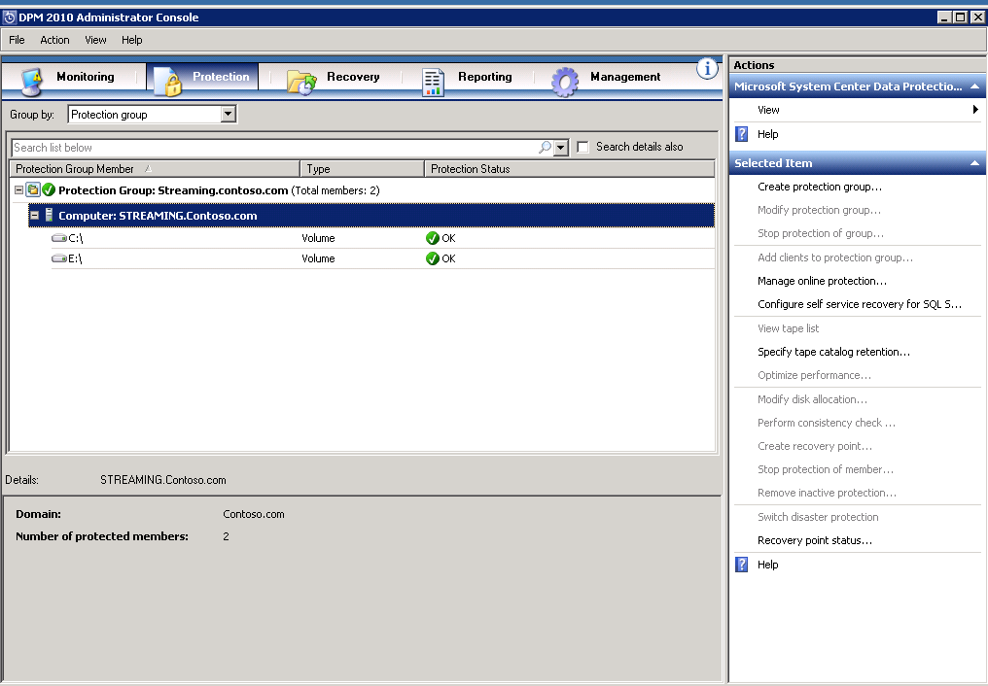

Figure 9: DPM 2010 Admin Console

1. Use the DPM admin console to add disks to the storage pool. Optionally, configure tape libraries.
2. Create DPM protection groups for each storage group to be protected.
3. Deploy the DPM protection agent on each computer that DPM performs backup and recovery on, per TechNet article: technet.microsoft.com/en-us/library​/ff399686.aspx. The protection agent could also be installed on server image prior to the server being provisioned. Specify short term and long term protection objectives.
4. For the DDC demo software that is installed later in this document, note that the protection group name must match the machine name for the demo.
5. DDC SERVICES – Toolkit

In this Section, we discuss how the DDC Toolkit can be used as a starting point for building a managed hosting solution that leverages management infrastructure built upon Hyper-V and System Center. The DDC Toolkit consists of Windows Communication Services (WCF) for virtualization, monitoring, configuration management. The Data Protection Manager component is implemented as a Windows service. These are all used by a Sample Silverlight © based application. The logical architecture of the DDC Toolkit is as shown below:



Figure 10: Logical Architecture of DDC Toolkit showing the DDC Services Layer interaction with Management and Presentation Layers

As can be seen in the above figure, the Management Layer consists of the management servers that are running Hyper-V, and System Center. Each of the management servers have an API that allows for programmatic access, and collectively is referred to as the Management Layer. The Services Layer in the middle interacts with the Management Layer using Microsoft WMI (Windows Management Instrumentation) API calls. In some cases, Power Shell© scripts may also be used to interact with the Management layer. Each of the services runs as a WCF Service within IIS 7.x and WAS (Windows Activation Service), or in the case of DPM, as a Windows Service. The presentation layer at the top provides the UI/UX experience. It communicates with the Management Layer through the Services Layer using SOAP/HTTP protocol. In most cases, the UI is a customer centric control panel or web based management portal. Additionally, an administrative interface is also provided for greater control and access to those with proper security rights. Finally, a sample Silverlight based web application is used to demonstrate how the services layer can be accessed using SOAP/HTTP calls to build a managed hosting application that leverages the power of Hyper-V and System Center.

There are various possible configurations for deploying the Services Layer in DDC Toolkit. The figure below shows one possible physical configuration for deploying the services, with each service deployed to its respective Management Server, and the Virtualization Service deployed to a Hyper-V Host.



Figure 11: Deployment Diagram Showing the various Services deployed to respective Management Servers/Hyper-V

In the next section we discuss high level tasks for installing the services layer, broken down into each of the various services. Please review the appropriate document for additional details and step-by-step instructions.

*This Section assumes that you have Access to the Sample Code folder from the DDC Toolkit downloaded from* <http://code.msdn.microsoft.com/ddc>

The following are pre-requisites for installing the services layer:

1. Note that all sample code is located at <http://code.msdn.microsoft.com/ddc>
2. Windows Server 2008 Host Server Running Hyper-V (for Virtualization Web Service) and corresponding System Center Management Server role for monitoring, configuration, and DPM services.
3. IIS Server role with IIS 6.0 Compatibility as shown in the figure below.
4. WCF Activation enabled as shown below.
5. .NET Framework 4.0 full install
6. Create an IIS Application Pool for each WCF Service.
7. Create a domain account for running each service. Grant necessary privileges to each of these accounts.
8. Admin rights on the server to install the service.
9. Install the clientaccesspolicy.xml file to the IIS root where the services are to be installed (usually \Inetpub\wwwroot). This is needed if you are calling services from Silverlight based application. A sample clientaccesspolicy.xml is provided in the DDC Toolkit.
10. Once the services are installed, verify that each of the services are running by invoking the corresponding WSDL in web browser.

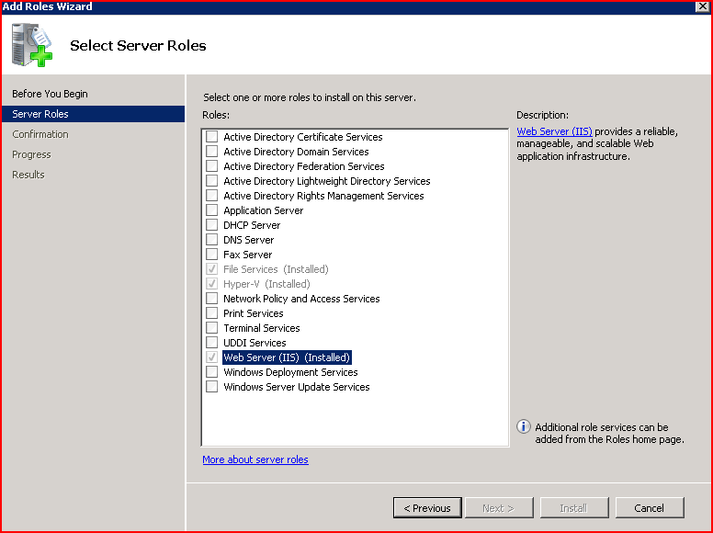

Figure 12: Ensure that the Web Server Role is Installed by using Server Manager Console

Also ensure that WCF Activation is checked as shown in the figure below:

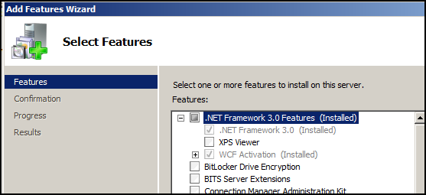

Figure 13: Ensure that WCF Activation is added as Feature using Server Manager Console

Also **ENABLE** IIS 6 Management Compatibility.

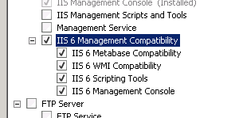

Figure 14- IIS 6 compatability

Create an application pool for each web service. The application pool must have administrative permissions for each system center product.

Note for all web services. The web services should be set to use anonymous authentication. The portal app must be set to use Windows Authentication.

* 1. Installing the SCVMM Service

The high level steps required for installing the SCVMM Service are as follows, for details on SCVMM deployment please refer to the appropriate product documentation:

1. Ensure that all Prerequisites are met, including creating application pool and domain account(s) needed as described in section 6.
2. On the server where you are installing virtualization service, run the following MSI package for the SCVMM Service: SCVMMServiceSetup.msi *[1]
3. At the dialog shown below, click Next.

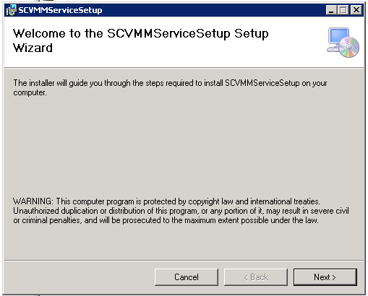

Figure 15: Virtualization Web Service Setup Dialog

1. Click on Next, and select Web Site (Default in this case), Web Application name, and Application Pool as shown below:

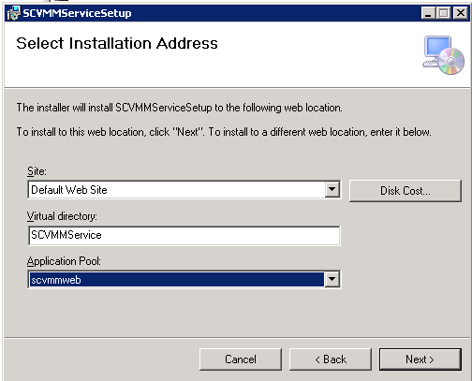

Figure 16: Virtualization Web Service Installation Option(s)

1. Select next twice to complete the installation.
2. Validate that the Virtualization Service has been installed correctly, by launching IIS 7 Manager (Start 🡪 Administrative Tools -> Internet Services Manager), Expand Default Web Site🡪 SCVMMService, and then selecting “Content View” tab in the details (content) pane (Middle), selecting “VirtualMachineManagementService.svc” and selecting “Browse” from the Actions menu on the right, as shown:

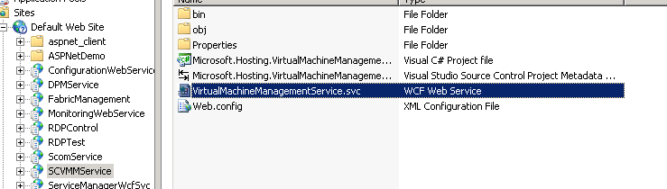

1. Verify that this web service is set to use anonymous auth in IIS.
2. Alternatively, you can launch IE (or any web browser), and go directly to :

<http://localhost/VirtualizationWebService/VirtualizationService.svc>

* 1. Installing & Configuring the Monitoring Service

The steps for each service are very similar. The high level Steps required for installing the Monitoring Service are as follows

1. Ensure that all Prerequisites are met, including creating application pool and domain account(s) needed as described in section 6.
2. On the Server where you are installing Monitoring Service, run the following MSI package for Monitoring Service: SCOMSvcSetup.msi *[2]
3. At the Next Screen, select appropriate Web Site, Web Application Name, and Application Pool.
4. Click Next twice to confirm and install the Monitoring Service.
5. Open the web.config in the folder where the monitoring service is located and set the SCOM server and account information for the service.
6. Confirm that the service works by launching IIS Manager, Selecting MonitoringService web application, and browsing MonitoringService.svc as shown below:

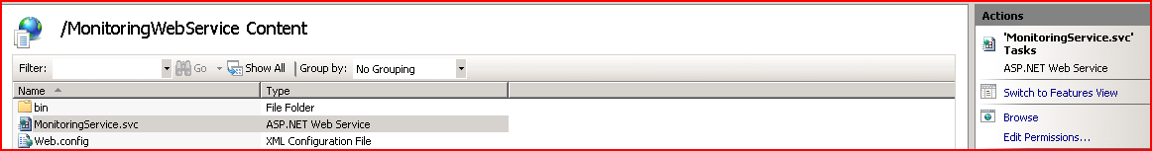

1. Alternatively, browse to <http://localhost/MonitoringWebService/MonitoringService.svc> on the server where you installed the Monitoring Service.
2. The monitoring service uses the Hyper-V Fabric MP.  Install the HyperV.Fabric.MP.xml management pack onto the SCOM server by importing from the SCOM MMC.



1. You will need the below Hyper-V MP’s and SCOM monitoring the hosts.

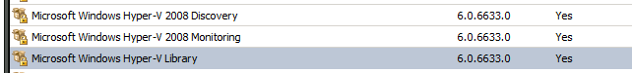

The management pack retrieves host based counters into SCOM as in the below chart.

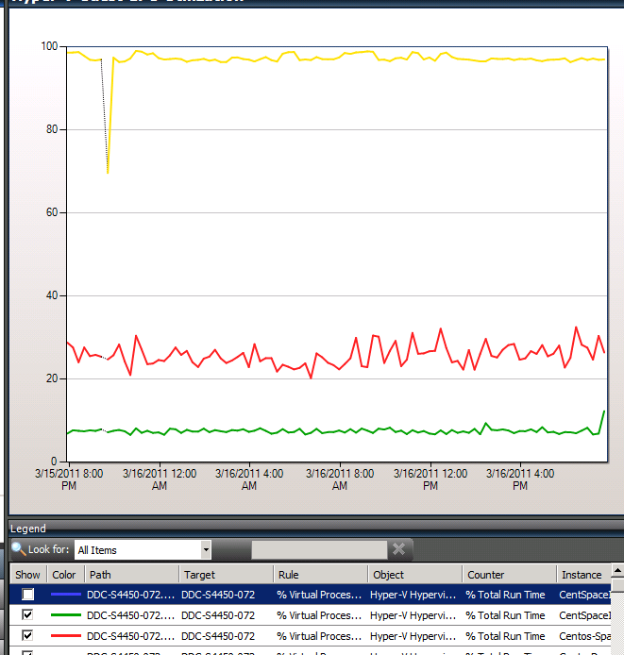

* 1. Installing & Configuring the Configuration Management Service

The high level Steps required for installing the Configuration Service are as follows, for details please refer to the appropriate documentation in DDC Toolkit:

1. Ensure that all Prerequisites are met, including creating application pool and domain account(s) needed as described in section 6.
2. On the Server where you are installing Configuration Management Service, run the following MSI package for Configuration Web Service: ConfigurationWebServiceSetup.msi *[3]
3. Select “Next” and enter the Web Site Address, Web Application Name, and Application Pool as shown below:
4. Select “Next” to confirm the installation.
5. Finish the Installation by clicking on “Close” button:
6. Verify that this web service is set to use anonymous auth in IIS.
7. Validate that the Configuration Service is running by using IIS Manager as shown below:

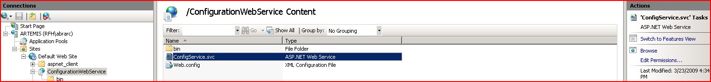

1. Alternately, browse to the web site <http://localhost/ConfigurationWebService/ConfigService.svc> and verify that the link is working.
   1. Installing & Configuring Data Protection Manager Service

The high level steps required for installing the DPM 2010 Service are as follows

Ensure that all Prerequisites are met, including creating domain account(s) needed as described in section 6.

1. On the Server where you are installing Data Protection Manager Service, run the following MSI package for DPM Windows Service: DPMSvcSetup.msi *[4]
2. At the Next Screen, select appropriate Web Site, Web Application Name, and Application Pool.
3. Select “Next” and confirm the Installation.
   1. Installing & Configuring Service Manager Service

The high level steps required for installing the Service Manager Service are as follows

Ensure that all Prerequisites are met, including creating domain account(s) needed as described in section 6.

1. On the Server where you are installing the Service Manger Manager Service, run the following MSI package for the Service Manager Service: SvcMgrSerup.msi
2. At the Next Screen, select appropriate Web Site, Web Application Name, and Application Pool.
3. Select “Next” and confirm the Installation.
4. Under the sample source DDTK\MP\UpdateVirtualMachineAssocations\ you will find UpdateVirtualMachineAssociations.exe. Copy this to the service manager server and set up a scheduled task to run approx.. every 5 min under the context of an account with service manager admin rights.

The application takes a single parameter which is the service manager server name.

Example UpdateVirtualMachineAssociations.exe svgmgr.contoso.com

1. Create an operations manager connector in service manager to sync VMM CI’s from operations manager. For simplicity you can name the connector OpsMgr as this name will be used in the next step.
2. Under the sample source DDTK\MP\SyncOpsConnector you will find SyncOpsConnector.exe. Copy this to the service manager server and set up a scheduled task to run approx.. every 5 min under the context of an account with service manager admin rights.

This application runs the ops manager/ service manager more frequently than the once a day sync that ships out of the box.

The application takes a single parameter which is the operations manager connector name.

Example SyncOpsConnector.exe OpsMgr

1. DDC Toolkit - Services

This section describes logical architecture of each of the Web Services for Virtualization, Monitoring, and Configuration Management, and DPM Windows Service in detail. The services are described in terms of their adherence to SOA principles, and using UML[5] diagrams for better understanding of the software architecture. The Services Layer of the DDC Toolkit is implemented using SOA principles, and contract (interface) based development, and is based on Microsoft’s distributed communication technology called Windows Communication Foundation (WCF). Contract based development is tenet of Service Oriented Applications (SOA’s) where the service is broken up into an “external” interface, and an internal “implementation”. The “external interface” is part of service capability or functionality that is exposed to the outside world. The implementation of the service is then an internal detail which external clients are not concerned with. Clients then interact with this service using external interface or contract. Contracts in WCF can be of different types. Service Contracts are a declaration of exposed behavior (methods), Data Contracts are used for persistent data exchange, and message contracts for structured messages, and Fault Contracts for communicating fault information. The WCF services for Hyper-V and System Center Suite are built upon this common foundation, and expose the following contracts as shown in the logical diagram below:

*A detailed description of WCF is beyond the scope of this documentation. For details please refer to documentation on MSDN, or the appendix for suggested reading.*



Figure 17: Logical Architecture of DDC Services Layer showing the Separation of Interlaces & Implementation

Figure: Hosting Services – Showing WCF Contracts provided, and Corresponding Implementation

WCF takes web services to the next level by providing unified programming model for building secure, reliable, and interoperable applications. It provides full support for latest suite of ws-* protocols, and thus can be used to interoperate with heterogeneous systems using open protocols such as soap/http based web services.

* 1. System Center Virtual Machine Manager (SCVMM) Service

The Virtualization Service provides a service oriented abstraction of underlying VMM platform. It runs on the web front end and is installed using the MSI package as described elsewhere in this document. Using the VMM Service, a client can do the following:

* Start Virtual Machine
* Shutdown Virtual Machine
* Take Snapshot of Virtual Machine
* Turn Off Virtual Machine
* Save Virtual Machine
* Mount Virtual Hard Disk
* Get Virtual System Configuration
* Perform Migrations
* Provision new virtual machines

The following Service Interfaces and corresponding Methods are implemented by the Virtualization ervice HDA:

Figure 18: Virtualization Service Contracts

**Data Contracts:**

The VMM Service implements the following Data Contracts:

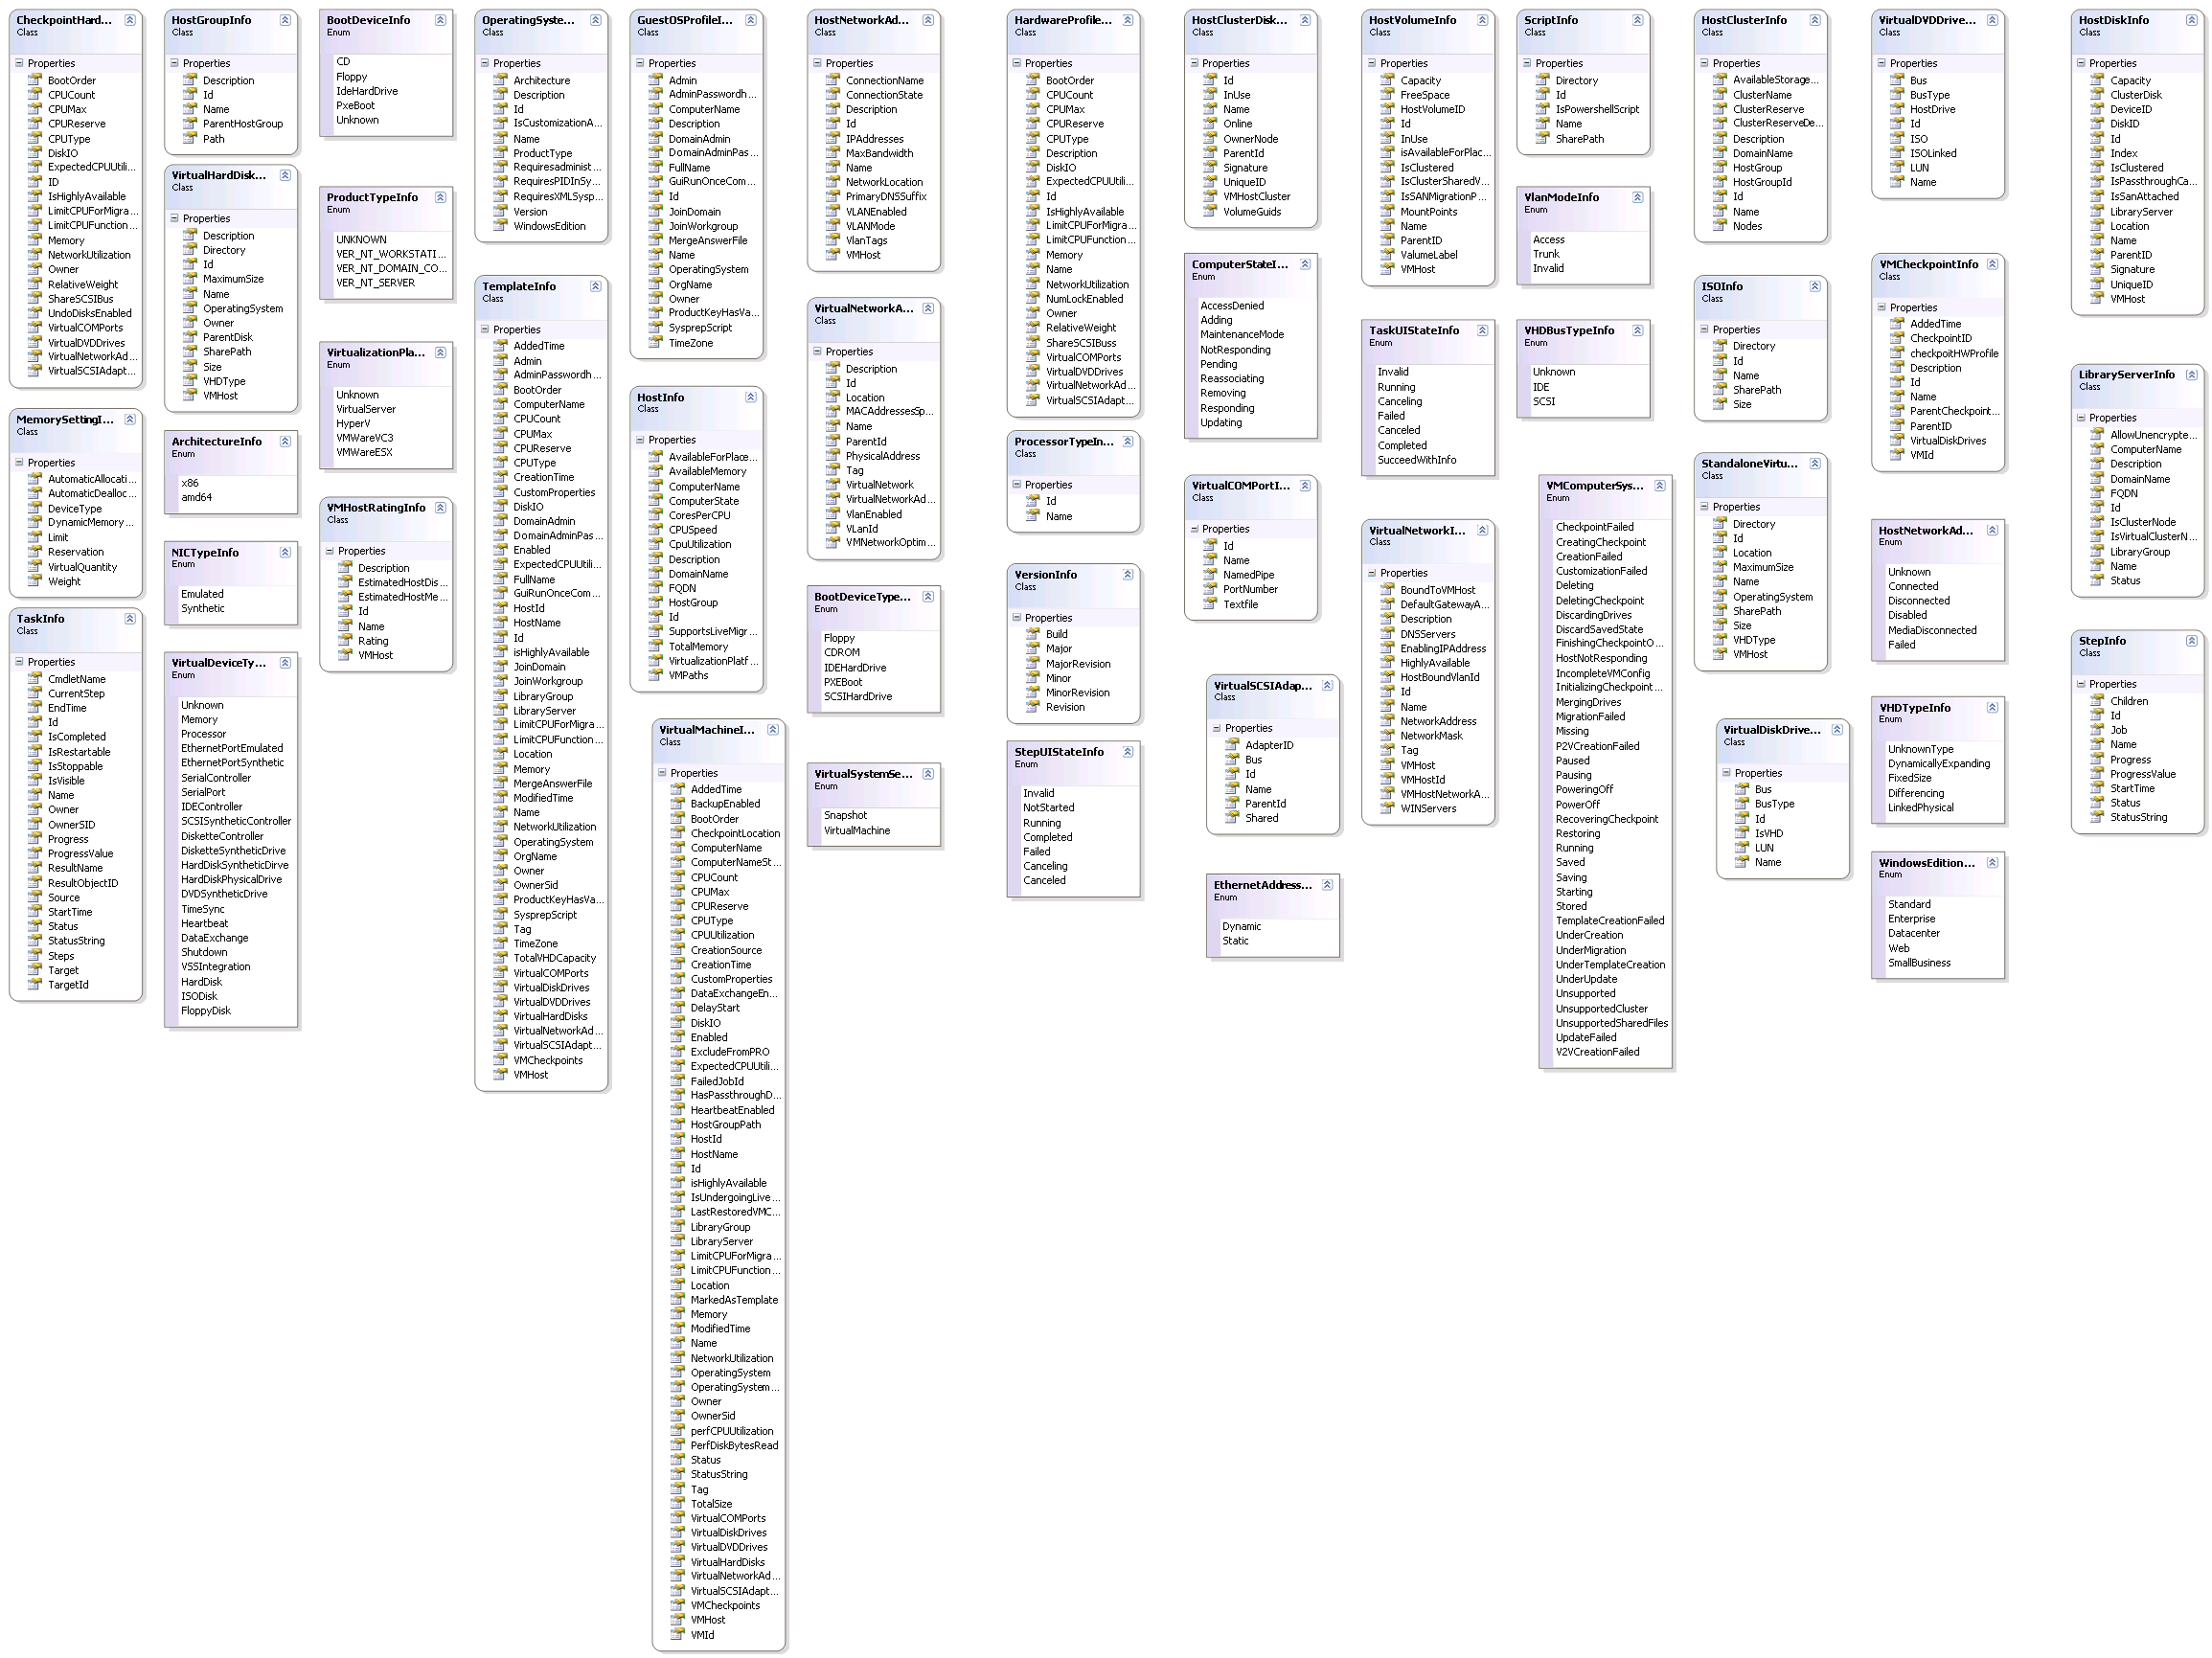

Figure 19: Virtualization Service: Data Contracts

* 1. Monitoring Service

The Monitoring Service provides access to the System Center Operations Manager 2007 R2 functions, and is installed on the Monitoring Server (SC-Operation Manger 2007 RMS) server.

The following UML Diagram represents the various classes, along with their fields and methods that comprise the Monitoring Service.

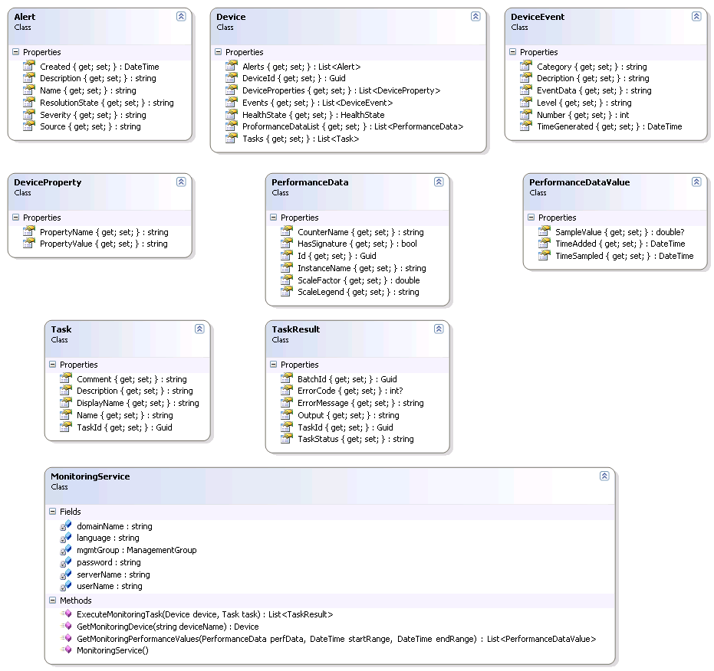

Figure 20: Monitoring Service UML Diagram

* 1. Configuration Service

Configuration Service, as the name implies, is used to provide service oriented way to access the System Center Configuration Management Server 2007 functions.

The following is UML representation of the classes and objects in the Configuration Service.

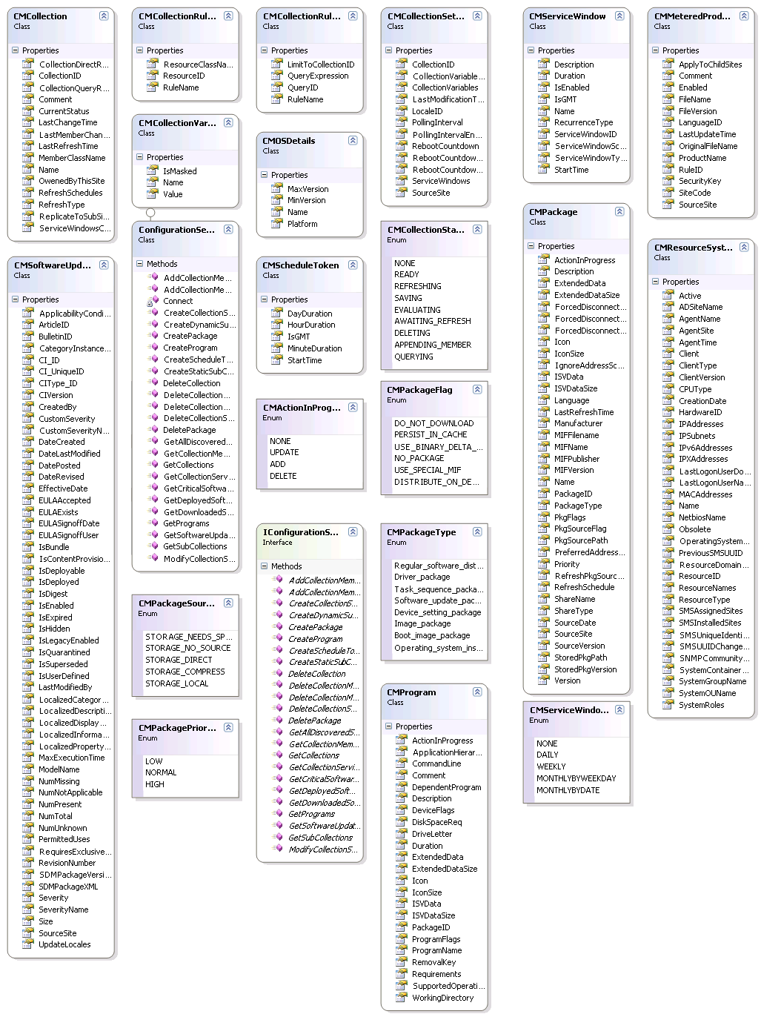

Figure 21: Configuration Service UML Diagram

2

* 1. Data Protection Manager Service

The following is UML representation of DPM Service:

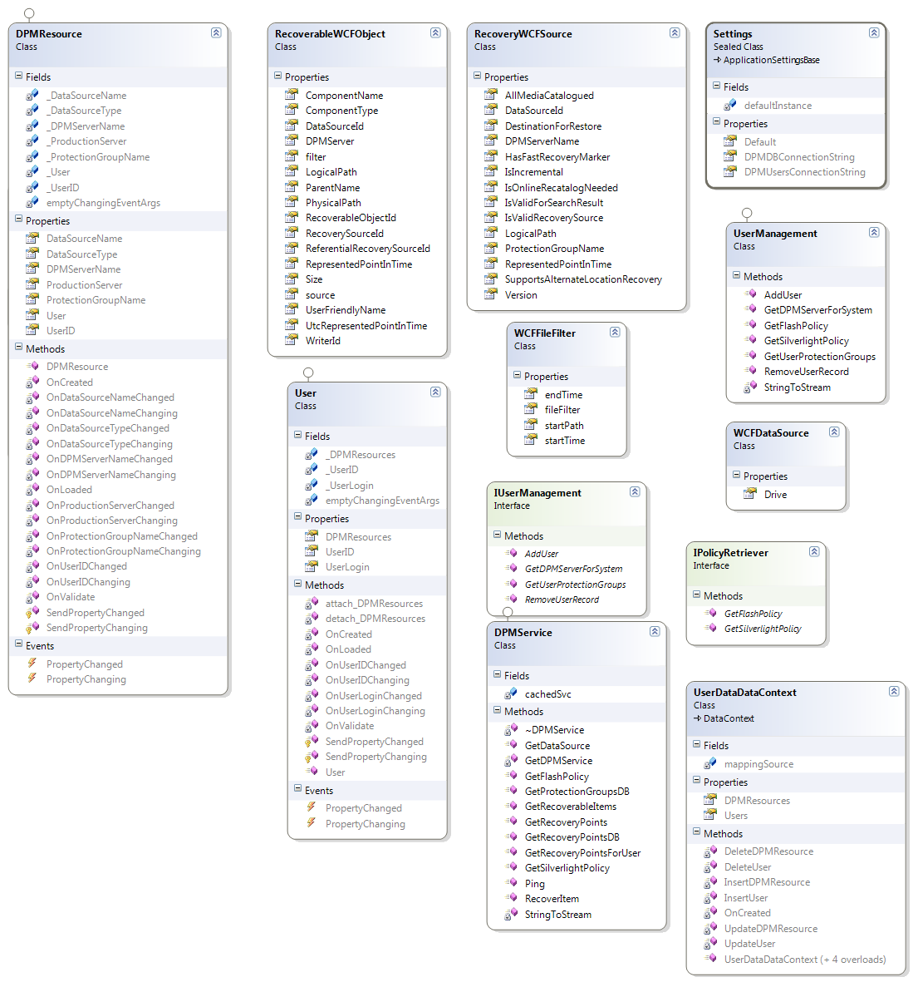

Figure 22: DPM Service UML

1. DDC CLIENT & CONTROL PANEL INTEGRATION

In order to integrate the backed services with control panel, the user needs to have access to development environment with a tool such as Visual Studio 2010 or other development environment installed. The specific steps required may be different depending on whether you are using Microsoft .NET platform or non .NET platform. The next sections discuss the process of setting up the environment for .NET platform, for other platforms such as Java/PHP, the steps maybe slightly different.

## Control Panel Integration from Microsoft .NET Platform

To get started with using the control panel from Microsoft .NET Platform, the following steps are required, depending on whether plan to use Silverlight based demo application as starting point, or integrate with your own .NET based control panel.

### Building Silverlight based Demo Application

The managed hosting demo application is built using Silverlight 4.0 to demonstrate how to create a managed hosting solution using Microsoft Hyper-V and System Center Products.

## Install pre-requisites

To build the Silverlight demo application, you need the following:

1. Visual Studio 2010

2. Silverlight 4.0 SDK

3. Silverlight Tools for Visual Studio 2010

4. Silverlight Toolkit

Download and install the Web Platform Installer

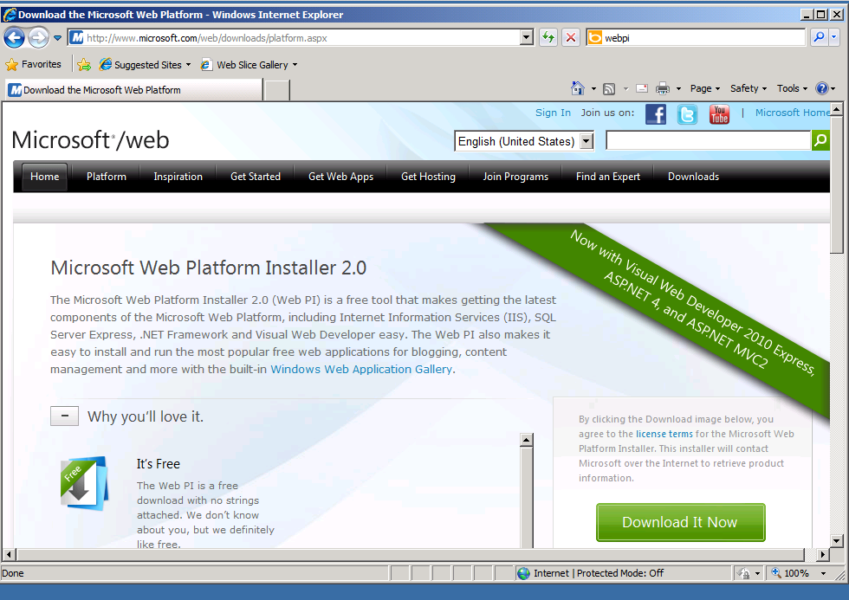

Launch WebPI and select the tools option

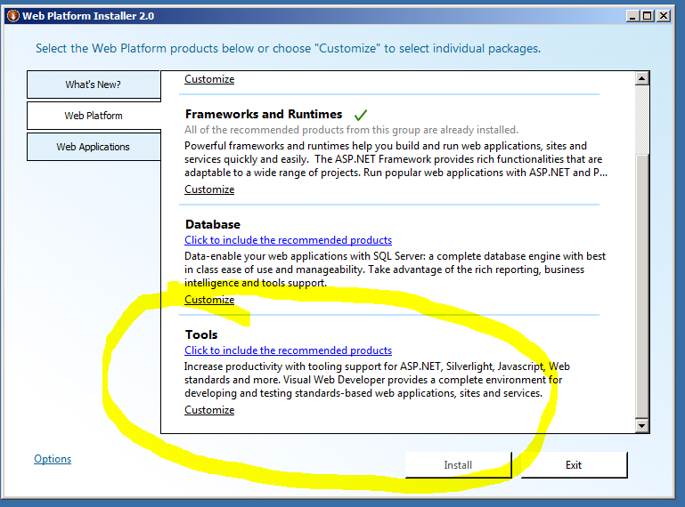

I

Install the Silverlight tools as well as WCF RIA Services Toolkit

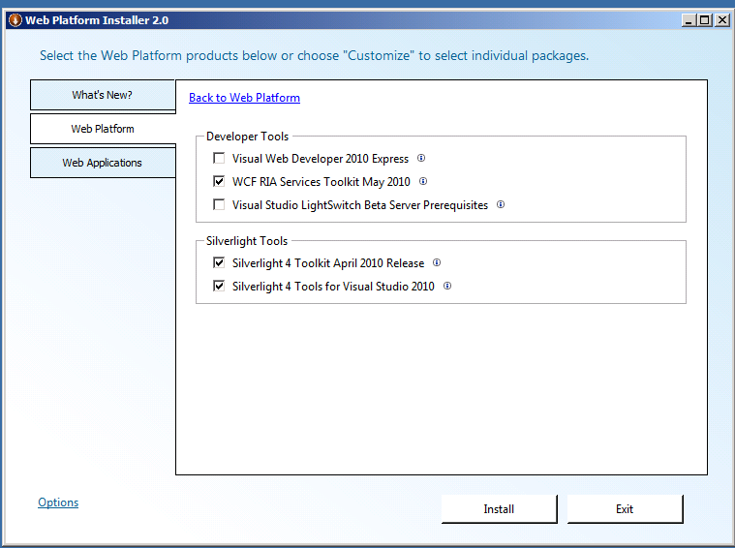

After you install the pre-requisites, you will need to install the management console for each System Center product:

System Center Virtual Machine Manager

System Center Operations Manager

System Center Configuration Manager

System Center Service Manager

Special instructions for DPM:

Install the DPM 2010 management shell, then install the dpmui.msi component onto the portal server. This installs the components needed for the WCF services o connect to the DPM 2010 server.

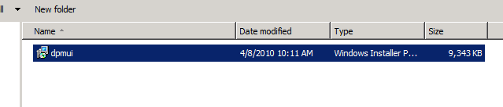

In addition, you need to deploy all web services contained in DDC toolkit for interfacing with various System Center Products.

## Installers

This are built when you build the installers in the DDTK solutuion

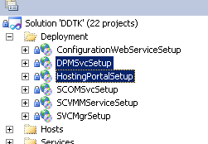

The Visual Studio solution for Silverlight UI sample contains two projects:

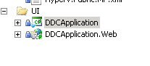

The DDCApplication and the DDCApplication.Web. One is the solverlight app and controls, the other contains the RIA services used bu the application. The installer for these is the HostingPortalSetup or may be deployed directly from visual studio for testing. Make sure the portal is set to use Windows Authentication and the web service are se to use Anonymous authentication in IIS.

1. Right click on each of the Web Service References, and select “Configure Service Reference”. Update the service reference to the correct web service end point for each of the services, as described in section 6, using the dialog shown below.

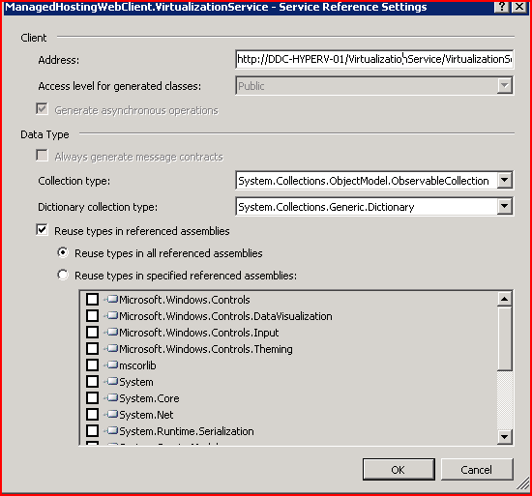

Figure 23: Configure Service Reference Dialog

1. Build and compile the application, and run it. Make changes to application as needed. The following collaboration diagram shows the interaction between the various objects.



Figure 24: Collaboration Diagram showing Demo Application interaction

#### Building your own ASP.NET application

Depending on the type of the Control Panel interface, there may be several different ways of integrating with the backend services. All of them require that you obtain a reference to the WCF Services that provide an interface to the management layer. In addition, Appendix A contains a sample hosted solution that integrates with various backend services.

1. **Integrating with Backend Services using Visual Studio 2008 SP1 IDE**: In this case you open the solution containing the existing or new control panel or web based portal, and right click on project, and select “Add Service Reference”. In the Service Reference, add the URL of the Service (.svc) file. (in this example, Virtualization Service) as shown below:

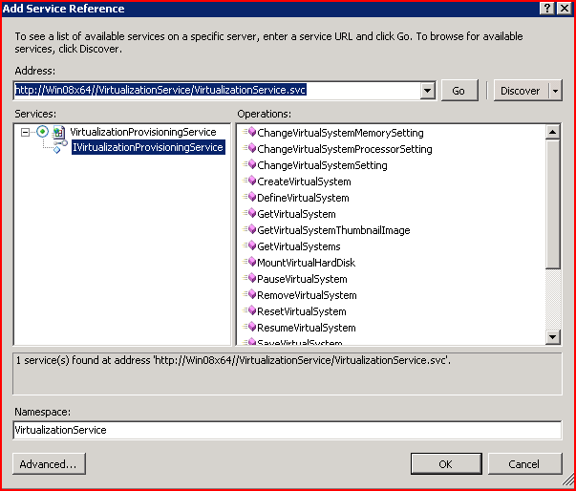

Figure 25: Add Service Reference Dialog

1. Adding the above reference will query the service for the interface, created a managed proxy, generate method stubs (both synchronous and asynchronous), and add it to your project. You can then use the proxy (client) to call the web service methods using strongly typed .NET types.
2. Repeat Steps 1-2 above to add reference to each of the other services. Note that DPM also exposes HTTP endpoint for integrating with soap/http based web services.
3. Alternately, you can use the “**svcutil**” tool to generate proxy. For details on using svcutil from Visual Studio Command Prompt, see the documentation on svcutil. The syntax for generating the managed proxy is as follows:

svcutil.exe <http://win08x64.contoso.com/VirtualizationService/VirtualizationService.svc?wsdl>

1. Once you have added the service reference, you can add the following declaration in your Asp.net code behind page as follows:

using ManagedHostingWebClient.VirtualizationService;

1. Create an instance of the web service proxy (client) and use it in the code. Use intellisense or Object Browser and Appendix B,C,D, and E to discover the interfaces and methods for each of the proxy objects as follows:

VirtualizationProvisioningServiceClient virtualClient = new VirtualizationProvisioningServiceClient("BasicHttpBinding_IVirtualizationProvisioningService",DemoContextManager.GetInstance.HyperVWebServiceAddress);

// Invoke Virtualization Method. Note that both Synch & Async methods are provided.

virtualClient.GetVirtualSystemsAsync(DemoContextManager.GetInstance.ServerName, DomainName, UserName,Password);

### Control Panel Integration from NON-Microsoft .NET Platform (example IBM/Java/PHP)

In order to integrate the control panel written on Non-Microsoft specific platform, you will need access to development platform with an ability to invoke web service call. All the web services are exposed over standard http binding, so any dev environment that allows you to make soap/http calls should suffice. Additionally, you may have to modify the config file for individual services to add additional behaviors. A sample web.config is shown below that support calling web services using Json to the Virtualization Service web.config.

      <system.serviceModel>

            <services>

                  <service behaviorConfiguration="Microsoft.Hosting.Virtualization.ServiceImplementation.VirtualizationProvisioningServiceBehavior" name="Microsoft.Hosting.Virtualization.ServiceImplementation.VirtualizationProvisioningService">

        <endpoint binding="wsHttpBinding" bindingNamespace="<http://Microsoft.Hosting.Virtualization.ServiceContracts/2007/04>" contract="Microsoft.Hosting.Virtualization.ServiceContracts.IProvisioningService"/>

        <endpoint address="ajaxEndpoint" behaviorConfiguration="AjaxBehavior" binding="webHttpBinding" bindingNamespace="<http://Microsoft.Hosting.Virtualization.ServiceContracts/2007/04>" contract="Microsoft.Hosting.Virtualization.ServiceContracts.IProvisioningService"/>

        <endpoint address="mex" binding="mexHttpBinding" contract="IMetadataExchange"/>

      </service>

            </services>

            <behaviors>

      <serviceBehaviors>

        <behavior name="Microsoft.Hosting.Virtualization.ServiceImplementation.VirtualizationProvisioningServiceBehavior">

          <serviceMetadata httpGetEnabled="true"/>

          <serviceDebug includeExceptionDetailInFaults="false"/>

        </behavior>

      </serviceBehaviors>

                  <endpointBehaviors>

                        <behavior name="AjaxBehavior">

                              <webHttp/>

                        </behavior>

                  </endpointBehaviors>

            </behaviors>

      </system.serviceModel>

The following attribute may also be need to the interface definition:

[WebInvoke(ResponseFormat = WebMessageFormat.Json, BodyStyle = WebMessageBodyStyle.Wrapped)]

1. If you are running Windows Account Control, you may have to launch the MSI package from command window and running it by right clicking it and using “Run as Administrator” command.
2. If you are running Windows Account Control, you may have to launch the MSI package from command window and running it by right clicking it and using “Run as Administrator” command.
3. If you are running Windows Account Control, you may have to launch the MSI package from command window and running it by right clicking it and using “Run as Administrator” command.
4. If you are running Windows Account Control, you may have to launch the MSI package from command window and running it by right clicking it and using “Run as Administrator” command.
5. UML is acronym Unified Modeling Language, and is used to model Software by showing the classes and interfaces, and the interactions between them.